Instruction for XDI-192N
- Press the NO.4 button. Enter into the QUICK.
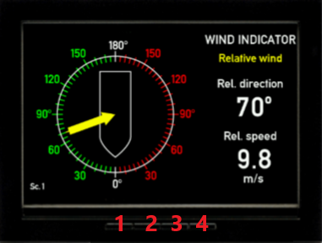
- In the QUICK interface, select USER MENU , and then press OK. Enter into USER.
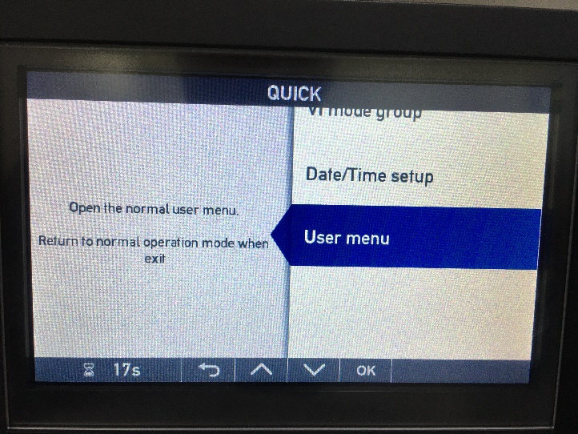
- In the USER interface, press NO.2&NO.3 at same time and keep 5 sec. Enter into INSTALL.
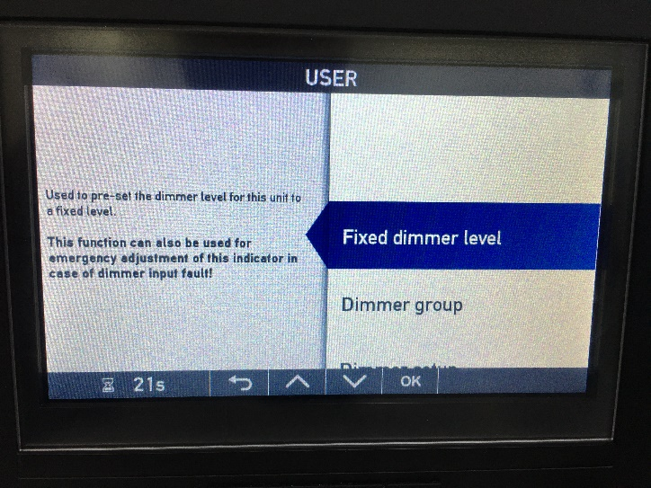
- In the INSTALL interface , select SERVICE, and press OK, enter into next page.
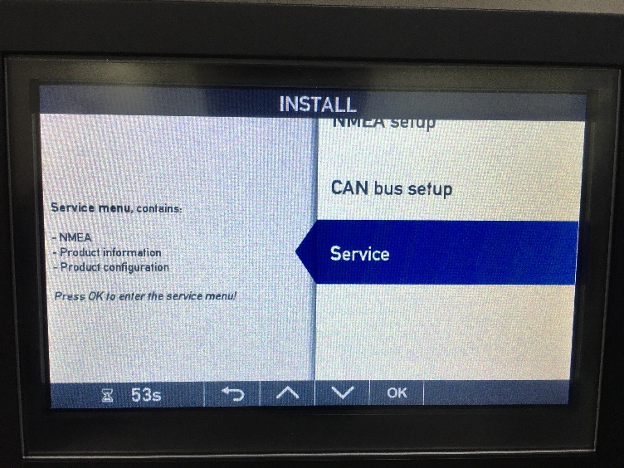
- In the INSTALL/SERVICE interface, select NMEA MONITOR, and press OK.
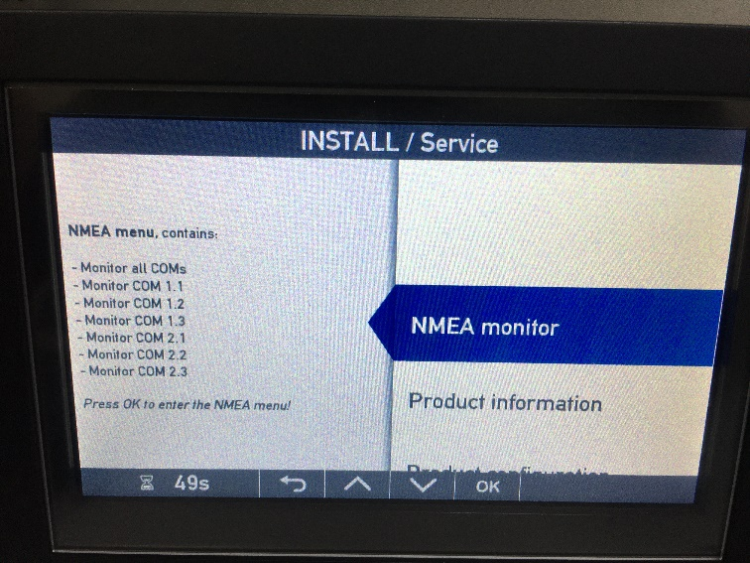
- In this page , select MONITOR ALL COMS, and press OK.
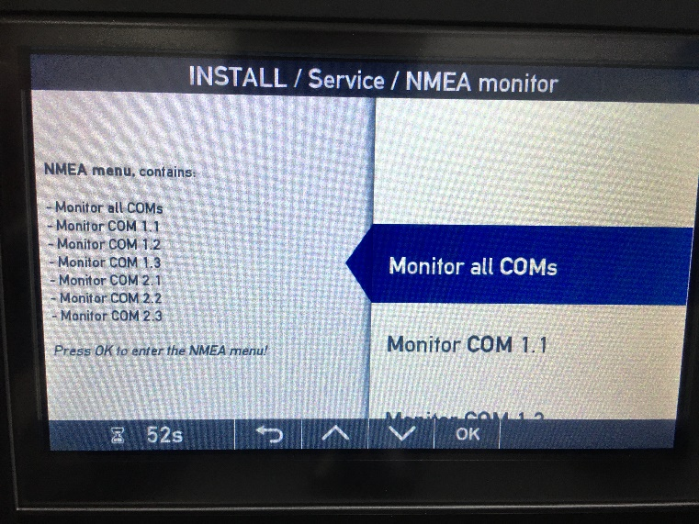

- In this page , you can check the NMEA sentence,
“RX” is indicate input signal from sensor, “TX” is indicate output signal to PLC.
please take a photo, and feedback to us.
