HAT SAT for WSS and XDi‐N
Test Procedure
Preconditions
When mounting the wind sensor WSS, the arrow on top (and bottom) of the white protection cap must point ahead towards the stem of the ship and be parallel with the centre axis of the ship. Note: An arrow pointing ahead is also found on the bottom part of the sensor itself.
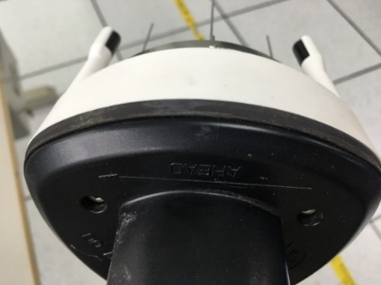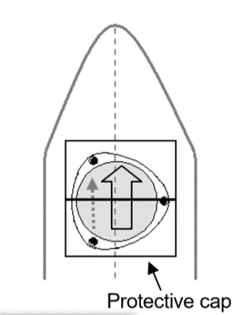
Please confirm the system connection is correctly following the Approval drawing. And then starting the procedure the weather station must already have been switched on. All connected sensors should be available and should indicate no fault condition.

Indicators
Mode shift
The button 1 is for mode shift.
NOTE: The 4 button functions on XDi-N :
1. Mode shift is used to toggle between indicator screens
2. Dimmer up (w/repeat)
3. Dimmer down (w/repeat)
4. Quick menu for unit shift and basic user setup
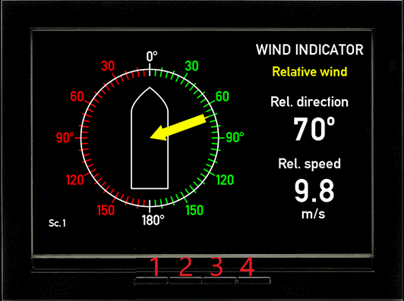
Test method:
Push the panel button 1.

Test result:
The screen can be changed between the three interface.
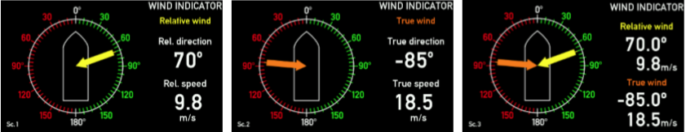

Test passed Test not passed
□ □
Remarks:

Dimming
The button 2 and 3 is for dimming.
NOTE: The 4 button functions on XDi-N :
1. Mode shift is used to toggle between indicator screens
2. Dimmer up (w/repeat)
3. Dimmer down (w/repeat)
4. Quick menu for unit shift and basic user setup
Test method:
Push the panel button 2 and 3.

Test result:
The backlight of indicators will be changed.

Test passed Test not passed
□ □
Remarks:

Wind direction relative
Test method:
Select on all LED Displays relative mode. Compare wind direction with other measure instrument.

Test result:
The wind direction on the connected LED Displays are same as other measure instrument.
Test passed Test not passed
□ □
Remarks:

Wind speed relative
Test method:
Select on all LED Displays relative mode. Compare wind speed with other measure instrument.

Test result:
The wind direction on the connected LED Displays are same as other measure instrument.

Test passed Test not passed
□ □
Remarks:

Wind direction and speed true

Test method:
Select on all LED Displays true mode. The wind sensor measures the relative wind speed and direction (yellow vector). If the ship’s speed (blue vector) is known, the effect on the wind measurement is the “speed wind” (red vector). The “true wind” (green vector) is calculated using the vector difference:
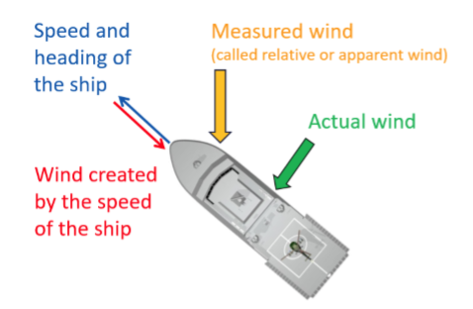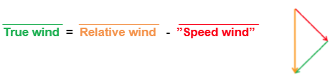
NOTE: When the speed of vessel is zero, the true wind is same as relative wind.

Test result:
The true wind direction and speed is right.

Test passed Test not passed
□ □
Remarks:

Unit changing
The XDi-N supports different selectable data units. The default presentation units are predefined in the three unit profiles. In the standard wind indicators it is the wind speed unit that is selectable via the unit profiles. Each unit profile contains default setup for all selectable data units that the XDi-N supports.
The default setup for the wind indicator is:
Profile 1: Wind speed in m/s
Profile 2: Wind speed in knots
Profile 3: Wind speed in Beaufort

Test method:
1. Push “4” button into QUICK interface;
2. To toggle to Profile 2, push the “4” button shortly and push “1” to go back to normal operation
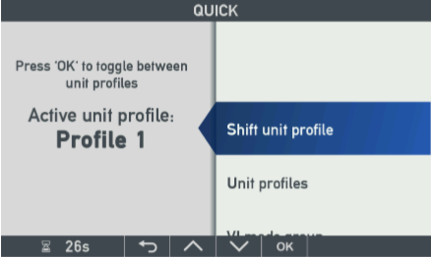

Test result: The indication mode will change to m/s, kn or Bft. The selected unit is displayed.

Test passed Test not passed
□ □
Remarks:

